Mediator Pattern
# Source: AI Source: Provided by: [Data Path: Persons Table -> ID Column: 1, Name_En Column: Motasem Essam] -> From: [ChatGPT] on [1/23/2026]
The Mediator Pattern defines an object that centralizes communication between multiple objects, preventing them from referring to each other directly.
👉 Think of it like an air traffic controller: planes don’t communicate directly with each other—they communicate through the controller.

🔑 Key Points
# Source: AI Source: Provided by: [Data Path: Persons Table -> ID Column: 1, Name_En Column: Motasem Essam] -> From: [ChatGPT] on [1/23/2026]
• Centralizes object communication
• Reduces direct dependencies between objects
• Promotes loose coupling
• Simplifies interaction logic

❌ Bad Example
# Source: AI Source: Provided by: [Data Path: Persons Table -> ID Column: 1, Name_En Column: Motasem Essam] -> From: [ChatGPT] on [1/23/2026]
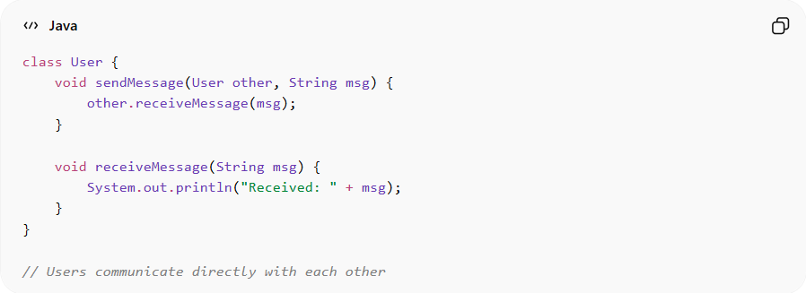
class User {
void sendMessage(User other, String msg) {
other.receiveMessage(msg);
}

void receiveMessage(String msg) {
System.out.println("Received: " + msg);
}
}

// Users communicate directly with each other
Problems:
• Tight coupling between objects
• Hard to manage communication in large systems
• Complex dependencies between multiple objects

✅ Good Example
# Source: AI Source: Provided by: [Data Path: Persons Table -> ID Column: 1, Name_En Column: Motasem Essam] -> From: [ChatGPT] on [1/23/2026]
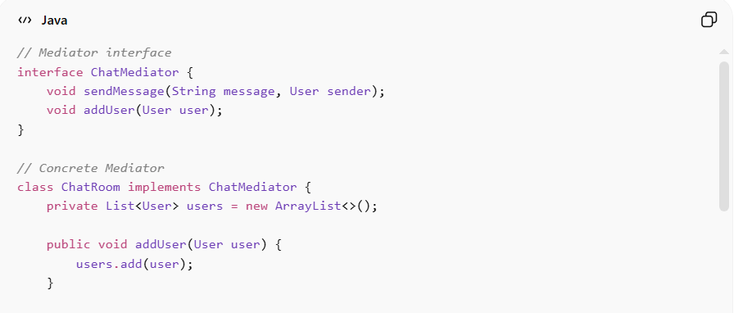
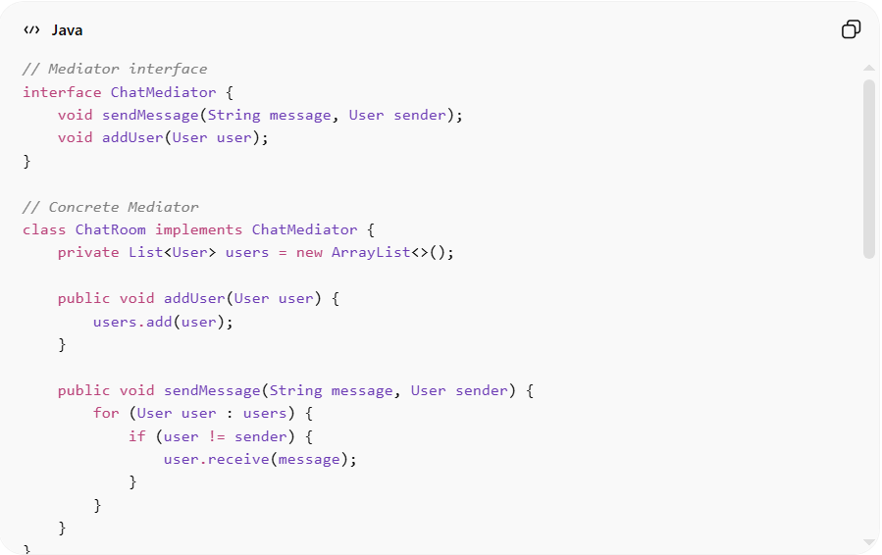
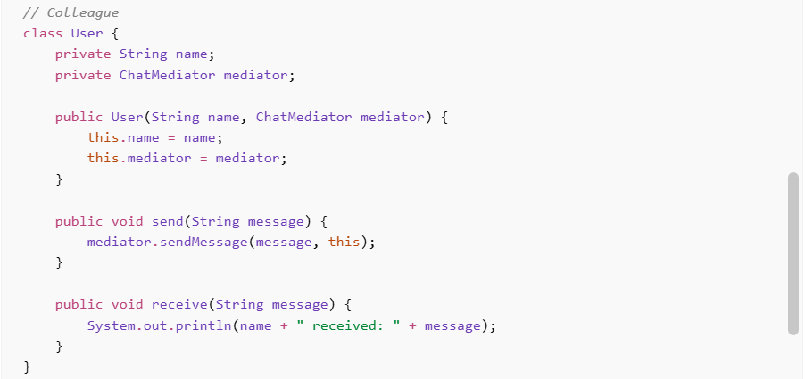
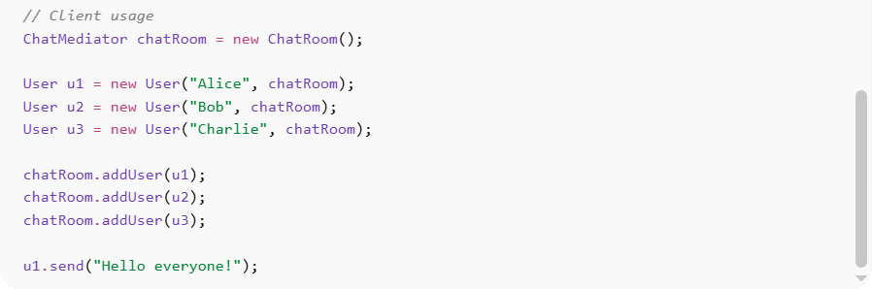
// Mediator interface
interface ChatMediator {
void sendMessage(String message, User sender);
void addUser(User user);
}

// Concrete Mediator
class ChatRoom implements ChatMediator {
private List<User> users = new ArrayList<>();

public void addUser(User user) {
users.add(user);
}

public void sendMessage(String message, User sender) {
for (User user : users) {
if (user != sender) {
user.receive(message);
}
}
}
}

// Colleague
class User {
private String name;
private ChatMediator mediator;

public User(String name, ChatMediator mediator) {
this.name = name;
this.mediator = mediator;
}

public void send(String message) {
mediator.sendMessage(message, this);
}

public void receive(String message) {
System.out.println(name + " received: " + message);
}
}

// Client usage
ChatMediator chatRoom = new ChatRoom();

User u1 = new User("Alice", chatRoom);
User u2 = new User("Bob", chatRoom);
User u3 = new User("Charlie", chatRoom);

chatRoom.addUser(u1);
chatRoom.addUser(u2);
chatRoom.addUser(u3);

u1.send("Hello everyone!");
Benefits:
• Reduces direct communication complexity
• Improves maintainability and scalability
• Centralizes control logic
• Makes system easier to modify and extend

⚡ Advantages
# Source: AI Source: Provided by: [Data Path: Persons Table -> ID Column: 1, Name_En Column: Motasem Essam] -> From: [ChatGPT] on [1/23/2026]
• Promotes loose coupling between components
• Simplifies complex communication flows
• Centralizes interaction logic
• Easier to maintain and extend

⚠️ Disadvantages
# Source: AI Source: Provided by: [Data Path: Persons Table -> ID Column: 1, Name_En Column: Motasem Essam] -> From: [ChatGPT] on [1/23/2026]
• Mediator can become a god object if overloaded
• Adds extra abstraction layer
• Can be harder to debug if logic becomes complex

🛠️ Use Cases
# Source: AI Source: Provided by: [Data Path: Persons Table -> ID Column: 1, Name_En Column: Motasem Essam] -> From: [ChatGPT] on [1/23/2026]
• Chat applications – messaging between users
• Air traffic control systems
• GUI frameworks – interaction between UI components
• Workflow systems – coordinating multiple services

